**CASE STUDY ON FINANCE MANAGEMENT SYSTEM**

**1 .Menu Bar :**

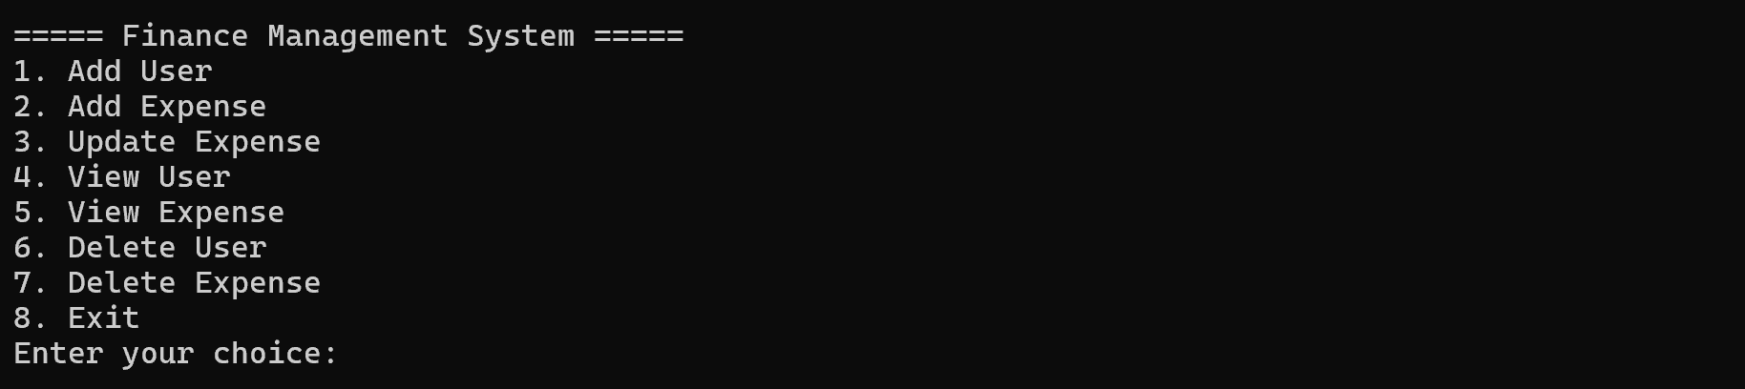

**2 . Add User :**

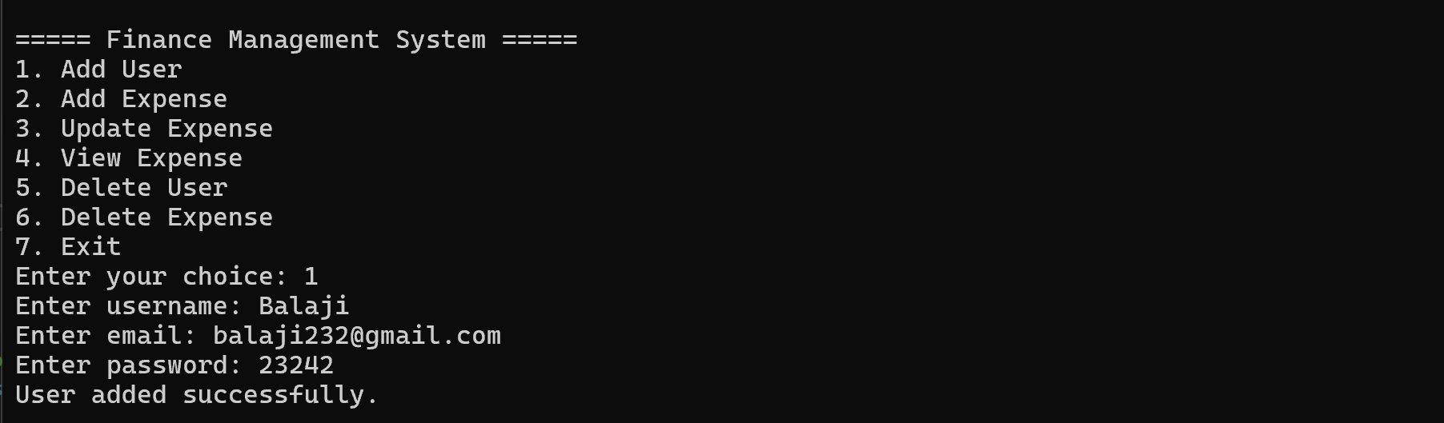

**3. Add Expenses:**

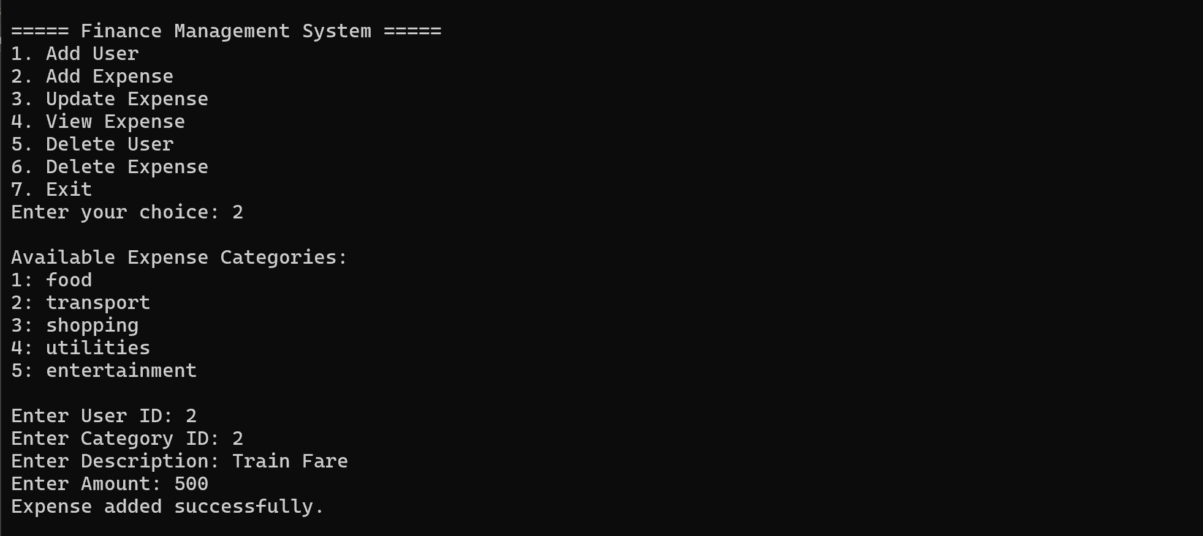

**4. Update Expenses :**

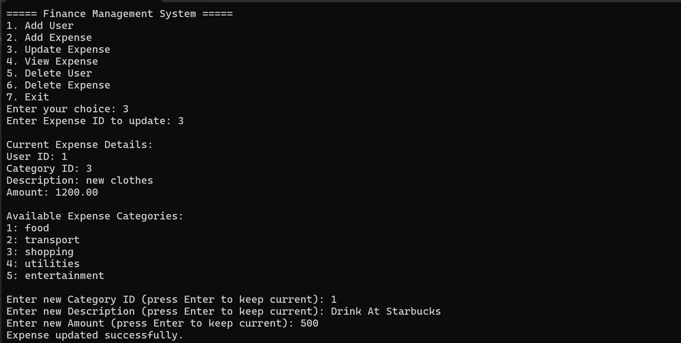

**5. View User:**

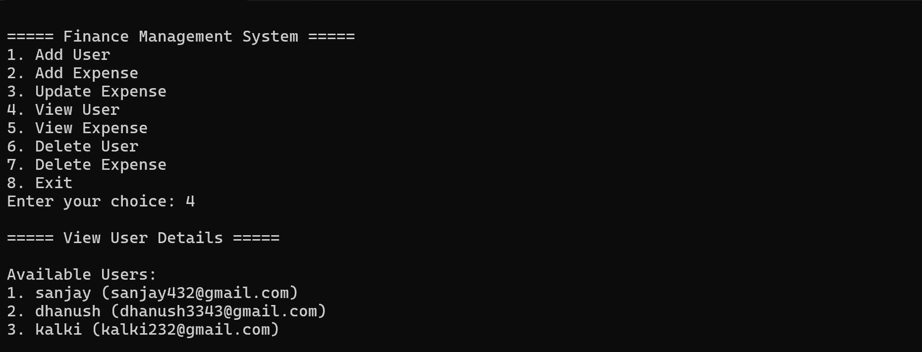

**6. View Expenses:**

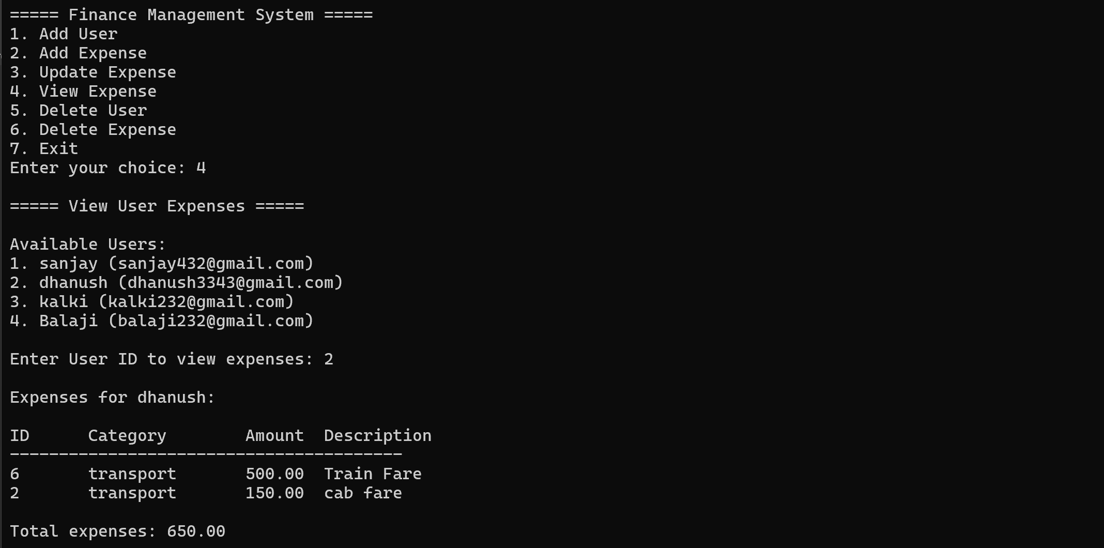

**7. Delete User:**

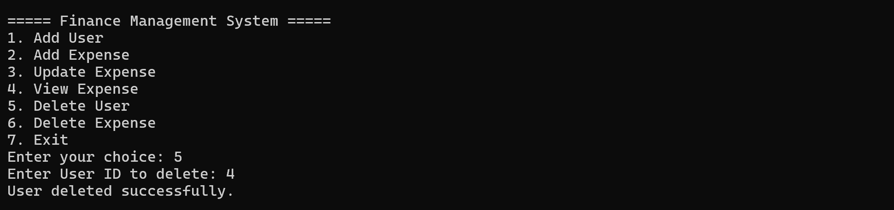

**8. Delete Expense:**

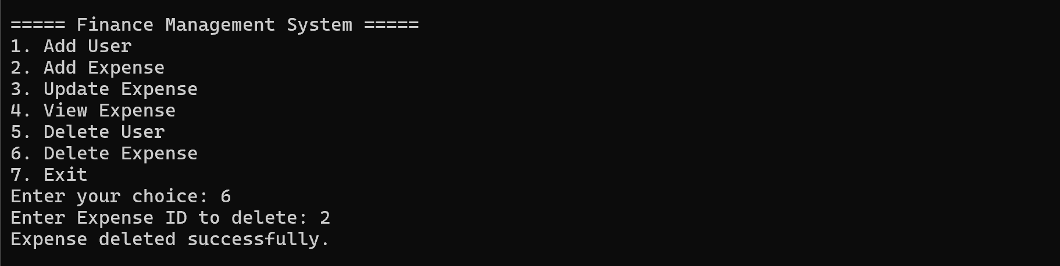

**9. NUnit** **Testing**:

